Minutes: Scottish Charity Regulator (OSCR) Board meeting, 21st April 2022 | 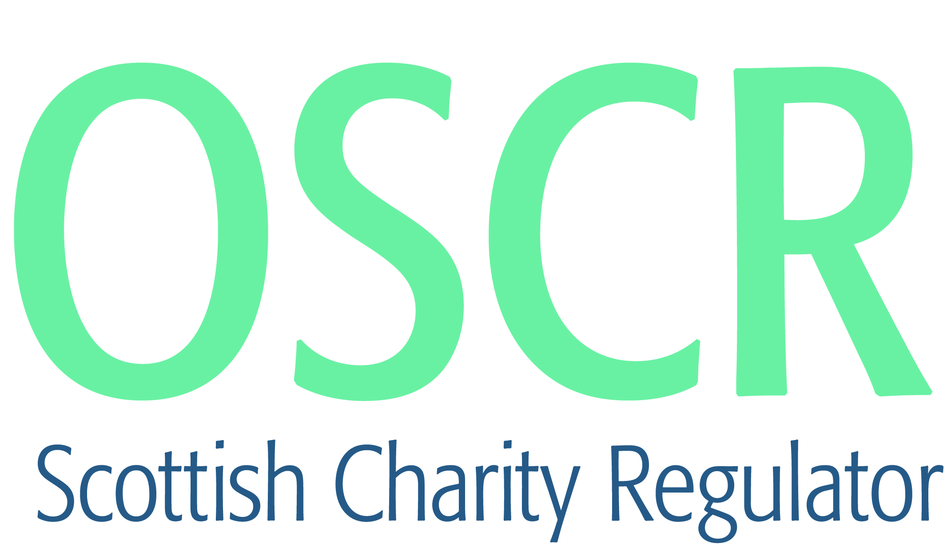

Board Members Present: George Walker (Interim Chair), Jill Vickerman (Deputy Chair Jessica Wade, Lynn Bradley,, Neil MacKay, Bill Maxwell, Robin Strang, Kirsten Howie

Apologies:

OSCR attendance: Maureen Mallon, CEO
Martin Tyson, Head of Regulation & Improvement;
Judith Hayhow, Head of Corporate
Finance Governance & Business Manager
HR & Learning Co-ordinator (item 5)
Senior Manager Communications & Digital
Senior Legal Advisor
Sector Improvement Manager

Board Secretary: PA to CEO

Private Business
Item | Area | Action
1, 2 & 3 | Chair’s introduction, welcome, declaration of interest, minutes from previous meeting and Action log  1. Declarations of Interest – None.  2. Minutes of Previous Meeting  It was agreed that going forward Minutes should be more concise, recording any Actions and Decisions, clearly and with a focus on collective decision making. It was also agreed that in future, the Action Log should include reference to the relevant Board Paper. | Board Secretary
4. | New Standards Commission Model Code  It was agreed that the Senior Legal Advisor would liaise with the SG Standards Office in respect of proposed amendment of Section 4.20 of the New Code. (Action) Subject to the changes discussed being made, the Board approved adoption of the code.  The New Model Code will be effective from June/July 2022. In the meantime Board Members should complete the Register of Interest on the basis of the current code, so that the information can be published on the OSCR website. (Action – Any outstanding Registers of Interest forms should be forwarded asap.)  Informed by the new code, the Board and Executive Team will hold a separate discussion session focused on effective joint working and expectations. Action | MM/Senior Legal Advisor
5. | 2021-22 Business Plan report on progress  The content of the report was considered, and the following were highlighted:  Hybrid Working - Board Members noted and approved the proposed post Easter change to Hybrid working, whereby all staff will be expected to work in the Dundee office for at least 2 days each week. At this stage it is not proposed to formally monitor staff attendance, or to set a further date for a review of the policy, since all agreed that the approach will evolve over time, in response to business needs, and reflect SG policy on remote working. It was agreed that Board Members would be given an update on how hybrid is working at future meetings (Action).  Change Projects - It was agreed than a progress update on the D365 project would be provided to Members once end to end testing had been concluded. The update should include information about the programme of actions and communications which will lead up to and support system launch. (Action)  In response to wider discussion about how and when the Board should be involved in considering major change projects, it was agreed that GW/JV/MM should set up an initial discussion to consider future procedures. (Action) | MM/JH/MT  Senior Manager Communications & Digital /JH  GW/JV/MM
6. | Draft Business Plan 2022-23  The draft plan was considered, and the document will be updated and circulated to Members by email. Subject to the agreed wording revisions, Board Members approved the Plan.  It was agreed that it would be helpful for the success indicators highlighted in the plan to be included in the OSCR KPI’s, and agreed that a review of KPI’s would take place to ensure this happened. (Action) | Finance Governance & Business Manager
7.  8.  9.  10.  11.  12. | Risk Register  It was agreed that the Register should be updated to reflect discussion earlier in the meeting around resourcing pressures. Board Members also agreed that the ARAC would lead on reviewing the Register, moving forward, with the full Board considering the actual register one per year. It was noted that the Risk Register content and style had recently been significantly refreshed, and the ARAC Chair confirmed that any further changes would be linked to a clear business benefit, and be informed by her considerable experience in this area. (Action)  Performance Indicator Proposal  There was considerable discussion around performance reporting during which it was agreed that measures in respect of the Business Plan - How we will know success, criteria, required to be added. It was agreed that performance requires to be monitored and reported at three levels – information we publish which gives an overview of our activities; information which the Board needs to gain assure that we are delivering the strategic objectives, and finally, operational management information which is used by our colleagues to monitor day to day activities and the use of resources, linked to the Business and Operational Plans. It was agreed that a performance report, based on the first two levels would be developed for consideration at the next Board meeting.  Notifiable Events Update  Board Members noted that an options paper in respect of how we consider and action Notifiable Events sent to us by Charities would be brought to the June meeting for consideration. Board Members discussed the purpose, assurance and risks associated with the current arrangements, and made suggestions as to the information which should be included in the forthcoming report. It was agreed that whilst the charity perspective on notifiable events is of interest, our regulatory interest, and the specific purpose of us receiving these notifications, together with a clear outline of the actions we will take on receipt, requires to be clarified and communicated. (Action)  The Gathering 2022  Board Members noted that The Gathering will be held on 15th June 2022. The event will follow a new format, and once further details are known these will be shared with Board Members, who are invited to attend. In addition it was noted that the Charity Awards will be held during the Gathering, and more information will be provided to Board Members over the coming days. (Action)  Internal Audit Report  Board Members noted the content of the 2021-22 Internal Audit Report, and that a Substantial Assurance rating had been awarded.  Review of Meeting and Papers.  Board Members made no recommendations in terms of the structure or content of Board Papers. The hybrid nature of the meeting had been slightly challenging for those joining remotely, however it was noted that this may have resulted from the quality of the technical equipment available at the venue. Looking ahead, and based on this experience, it was agreed that it would be preferable for meetings to be either in person or fully remote, and arrangements will be made on this basis in the short term. (Action) | Finance Governance & Business Manager/LB  Finance Governance & Business Manager /JH  Sector Improvement Manager /MT  Sector Improvement Manager  Finance Governance & Business Manager /PA to CEO

